Higher Education
Name.
Institution.
Date.

Higher Education
Question 1
University Brand – University of Virginia
The competition for higher education institutions has continuously been increasing. Students are always in search of a university that fits their desired goals. As such, universities and colleges are constantly challenged to create a brand that attracts more student enrollment. This approach is used as a marketing strategy to create a stable identity. The unique identity enables students to decide why the institution is the best as compared to others. One example of a real university that has developed its brand is the University of Virginia. This institution is research-driven and attracts diverse students from across the country. The following is the university’s logo:
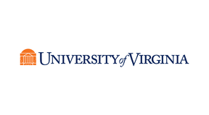
The logo includes a symbol of the university’s main building and its name. The symbol enables the public to associate different products with the university. For example, this logo is printed in books and sports’ uniform. Hence, if the team wins, people associate success with the organization. As a result, this brand attracts students who are interested in sports. The picture below portrays the university’s football team:

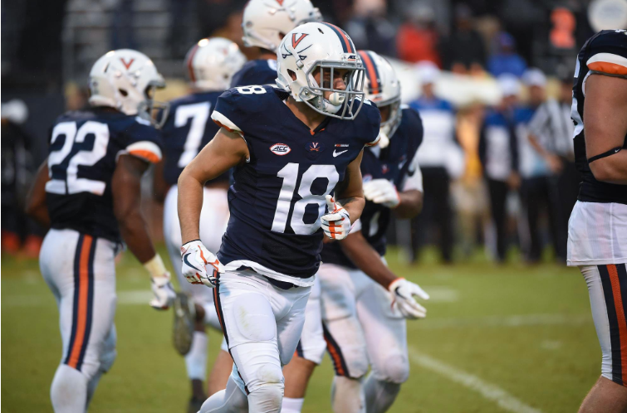
The image below shows a sample of the university’s building which also contributes to its brand. 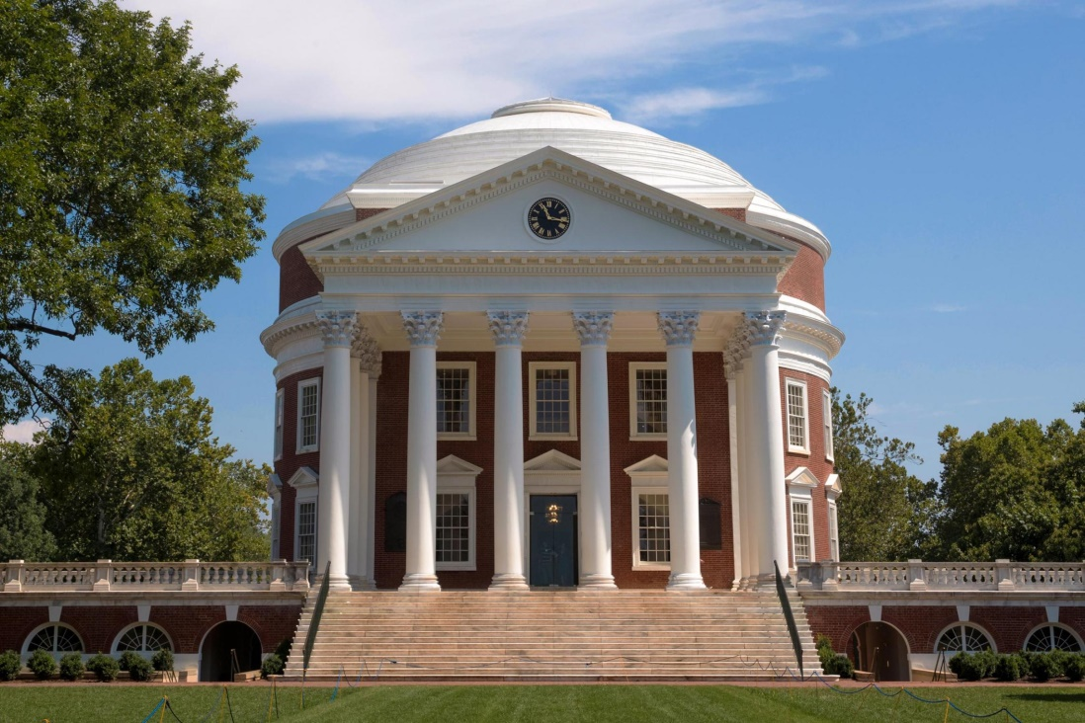
The picture is an ancient building which was designed by the founders in the early 1820s to represents authority. It also acts as a landmark that directs new people to the institution. Also, the surrounding buildings are well placed to give the university a perfect design. These buildings are designated for academic purposes, and this portrays the goal of the institution, which is to offer quality teaching (University of Virginia, 2015). Besides, the graduation ceremonies are conducted near this area to give further meaning to the image.
The university’s brand is also enhanced by the website, which indicates all aspects of the schools. This aspect is essential because it enables the organization to market its services. Visitors can find all information, including research, sports, enrollment, and other activities. The picture below is the front page of the website.
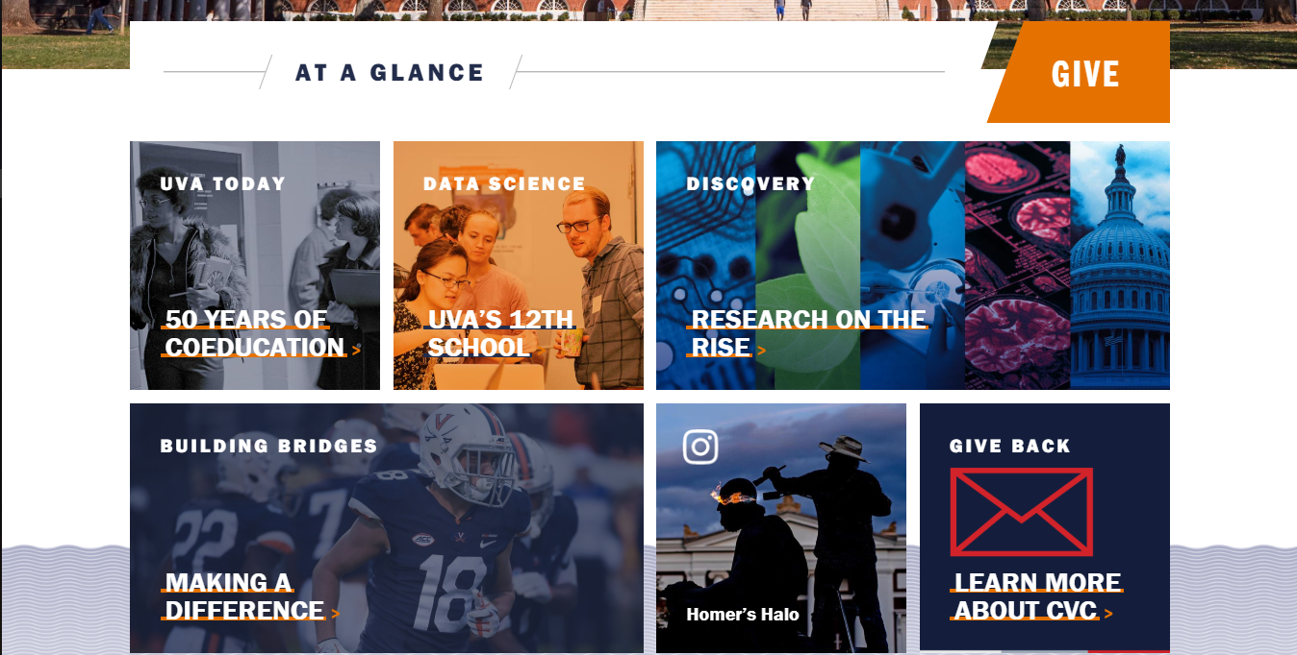
Question 2
Strategy for Building University Brand
Most universities are working on effective strategies to build their brands and maintain their reputation. One of these organizations is Arcadia University in Pennsylvania. This institution began as Beaver College in 1853. By 1985, the college was able to produce qualified young man and women graduates. However, it suffered financial loss, and the management began to develop strategies to improve its brand. Some of these measures included upgrading the website and improving facilities such as sports and accommodation (Erdoğmuş & Ergun, 2016). This approach enabled the organization to increase student enrollment. Nevertheless, these moves were not enough to reach its goals.
In the early 2000s, the college began to review its name. Most people ridiculed it and associated it with names such as rodents. These aspects affected enrollment since some students were not attracted to the name. The college changed its name to Arcadia and updated its status to a university. This new brand portrayed the organization as a learning environment and attracted potential students (Judson et al., 2016).
The university continues to keep its reputation by assessing its services and student performance. For example, in the 2013 – 2018 strategic plans, the university included more funding to improve teaching and learning practices. This plan also included an increase in scholarships which is an approach to attract more students and boost the university’s reputation (Erdoğmuş & Ergun, 2016).
Question 3
Student Market
A student market can be described as a pool where education stakeholders can identify potential learners and develop strategies to attract more enrollments. As such, universities define their priorities and build a brand to attract specific students. Universities also consider students as consumers of the organizations services and products. Some of the strategies used to attract more students include creating an informative website and interacting with individual students. Additionally, this approach enable the organizations to improve their quality of services to produce qualifies graduates who help to further market the brand.
One of the universities that have managed to grow its university market is The University of Southern Mississippi. In 2016, the university had a head count of 11,779 students. This number increased to 11,815 the next year and in 2018 there was a head count of 11,920 students. This enrollment is sustainable because it shows that the universities strategies are effective to maintain an increase of the institution. Hence, this statistics is likely to increase the institution’s revenue.
Discussion Topic
The implication of Fake Citation on the Reputation of a University
Students are always warned from cheating and using the wrong citations in their work. This malpractice affects their performance and may lead to discontinuation of their degree. Nevertheless, plagiarism also affects diverse committee members and the entire reputation of a school. The article by Collen Flaherty on Fake Citations Kill a Career demonstrates some of the implication of cheating. Flaherty (2019) describes how Armstrong’s book regarding the history of North Korea did not include the right citations. Additionally, the author had studied in Columbia University and worn an award associated with this book.
This type of findings affects the reputation of the university where the author studied because the committee members in charge of investigations are expected to notify the public about the malpractice (Flaherty, 2019). As a result, universities associated with this image may affect students’ acceptance in the job market. Some companies may deny the students admission for internships and employment. As such, faculty leaders have the challenge to implement policies that ensure students do not copy exact publications from other authors.

Reflection and Practice
Committee Structure for the Start-up University
Education Committee
Academic Appeal
Research Committee
Audit Committee
Disciplinary Committee
Governance Committee
Student Appeal Committee
Finance Committee
SENATE
COUNCIL

The university committee will be dived into the council and state. The council will also be divided into four departments to manage the different operation. First, the audit committee will be in charge of verifying financial records and risk management in the university. Second, the financial committee will guide the use of the university’s funds. Third, the student appeal will ensure that decisions regarding student disciplinary are fair and provide guidance. Finally, the governance committee will develop and review policies to ensure effective performance of the board of trustee (Judson et al., 2016).
The Senate committee will also be divided into four departments. First, the education committee will manage policies related to teaching and learning. Second, the academic appeal will monitor and confirm that students follow the right guidelines to produce quality information. Third, the research committee will implement ethics and laws that relate to research. Finally, the disciplinary committee ensures that the rules and regulations of the university are followed (Judson et al., 2016).
Conclusion
In conclusion, the university brand plays a critical role in attracting potential students and stakeholders. As such, the organization’s leaders have to develop and implement strategies that aim to improve the brand. Besides, these strategies should be continuously revised to cope with competition from other universities. Additionally, diverse committee members should play their roles and guarantee quality in performance. Effective implementation of these procedures will promote quality and prevent issues that may negatively affect the university’s image (Lombardi, 2013).

References
Erdoğmuş, İ., & Ergun, S. (2016). Understanding university brand loyalty: the mediating role of attitudes towards the department and university. Procedia-Social and Behavioral Sciences, 229, 141-150.
Flaherty, C. (2019). Fake Citations Kill a Career. Inside Higher Ed. Retrieved from: https://www.insidehighered.com/news/2019/09/13/columbia-says-historians-acclaimed-book-north-korea-was-plagiarized-publisher-says
Judson, K. M., Aurand, T. W., Gorchels, L., & Gordon, G. L. (2015). Building a university brand from within: university administrators' perspectives of internal branding. Services Marketing Quarterly, 30(1), 54-68.
Lombardi, V. (2013). How Universities Work. Baltimore: Johns Hopkins University Press.
The University of Virginia. (2015). University of Virginia. Web Accessed from https://brand.virginia.edu/

